Functional User Stories

DOD Portal

This document describes the Functional Solution of the system. The document intends to outline the solution by incorporating user stories and screen designs for the project as agreed between the Business Application Owner, all other impacted parties and the IT community.

Version 0.2

# Document Control

The latest published version of this document is located here:

|  |  |  |  |
| --- | --- | --- | --- |
| **Version** | **Date** | **Author** | **Comments** |
| 0.2 | 28/01/2016 | Arshyad | Create |
| 0.3 | 08/02/2016 | Adrian Buttigieg | Review |
|  |  |  |  |
|  |  |  |  |
|  |  |  |  |

AB 10/02

* Shad / MAY – Pls get together and have a go at oputting togerthr and ER diagram?
* Shad - Pls update screen designs for mobile only
* Puja / Shad – pls add Settings page include Celsius / Fahrenheit, Support Page, Release Notes, User credientials & Setup
* Puja / Shad – Consideration for Data pulled from DOD for HACCPS

# Contents

Document Control 2

Contents 2

Executive Summary 2

Background 2

Business Objectives for this Project 2

Scope 2

Definition of Points 2

Supported Platform 2

PLAN 2

Stage 1: Administrating DOD devices 2

1.1 Configuration – User Roles 2

1.2 Configuration – Browse by sites 2

1.3 Configuration – Adding DOD devices 2

1.4 Configuration – Viewing DOD devices 2

1.5 Configuration – Alerts 2

Stage 2: Reports 2

2.1 Reports – view by site **Error! Bookmark not defined.**

2.3 Reports – view by DOD 2

Timeline 2

Appendix 2

A2 Decisions & Implications 2

A3 Definitions, Acronyms and Abbreviations 2

A3 Table of figures 2

A4 References 2

Executive Summary

This section is for an Executive Summary. It may be easier to first complete the Detailed Functional Solution and then complete the summary.

Background

Defrost On-Demand (DOD) devices are peripherals attached to refrigeration assets that are held on store premises. The purposes of these DOD devices is to collect temperature data from those refrigeration devices, which can be used to monitor and diagnose the state of the refrigerators.

Business Objectives for this Project

* Use the source content from the Business Solution Management Report (BSMR for 4QD) or High Level Requirements.& Solution Definition (HLRSD) document

To develop an application to administer, monitor and report on DOD devices. The web applications are to be responsive accessible from web browser.

Scope

This document has been created to detail the requirements related to the development of a DOD web application. This document has also been used to break the project into different stages and estimate each.

Definition of Points

To estimate the development effort of the DOD application, each user story was reviewed (As per scrum methodology – for a maximum period of 2mins) and points were assigned. Points are an Agile concept to express how complex the development team believes a requirement is. Points are used to indicate a scale, 1 indicates a simple task and 13 being the most complex. (Based on the sequencing of Fibonacci) This number was then loosely related to hours. As development continues the estimation of effort will continue to change as requirements are refined and discovered.

Supported Platform

DOD web application will be developed to support the following versions and above :-

1. Google Chrome 34+
2. Internet Explorer 10+
3. Safari 10+

As responsiveness is a priority for the DOD the mobile version of the above browsers is also to be supported.

Application development platform

* The application is to be devloped using the following
  + MS SQL Server 2014 in Azure PAAS.
  + MVC 4/5
  + AngularJS, Node.js, TypeScript 1.0
  + C# .Net
  + Java Script, JQuery
  + HTML5

PLAN

|  |  |
| --- | --- |
| Item | Status |
|  |  |
|  |  |
|  |  |
|  |  |
|  |  |
|  |  |
|  |  |
|  |  |
|  |  |
|  |  |
|  |  |
|  |  |
|  |  |
|  |  |
|  |  |
|  |  |

# Stage 1

**Objective :** Browse stores. Add, view, and edit DOD devices.

**Total Point:**

**Total Hours:**

**Weeks:**

## Landing Page/Main Menu – A user has access to key elements of the application

(Points: )

* The user has the ability to preview store configured for in the header of the application
* The user can **change site** , this filters information within all screens
* The user can view **Recent Alerts** for the store with a counter for the last 24hours
* The user can **add DOD** to a site
* The user can **view/modify DOD settings**
* The user can view **reports**
* The user can **configure alerts**
* The user can **change settings**
* Additional features made available on the burger menu.
  + The user can **logout** of the application therefore removing credentials from cache
  + The user can login. A login page should be made available on open of the application prior to seeing the landing page/main menu

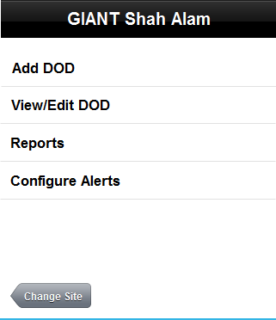

* Add DOD – A technician can add DOD to a site. Clicking on Add DOD leads to the DOD Set-Up screen (Figure 2).

## Configuration – A user can change site

(Points: )

* A user can view the store type with a counter of the total number of sites (Image Required). This can be selected to then open a list of stores for that store type

Figure 1: Store list view (on mobile).

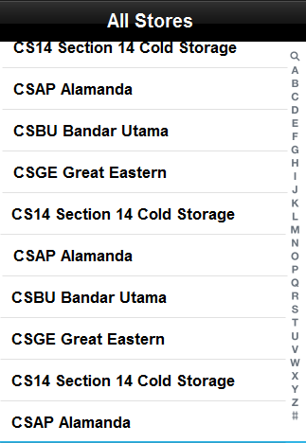

* A user can click on a store. This will return back to the Landing page/Main menu.

Figure 1.2: Site view

## Configuration – A user can add a DOD device for the site

(Points: )

A user of role “Technician” are able to add DOD devices to a site. The form holds the following fields:

* Serial number – alphanumeric mandatory field, restricted to x characters.
* Asset tag – numeric, mandatory field, restricted to x characters
* Location
  + Describes the host device
  + Alpha numeric (Free txt), mandatory field, restricted to x characters
* Parameters
  + Can be defined by the user. Ability to add a parameter and define type (e.g. numeric (integer, text, alphanumeric, decimal) date, combo box, photos, attachments) ability to flag if mandatory, restrict to x characters

Figure 2: The Add DOD screen, as viewed on a desktop browser

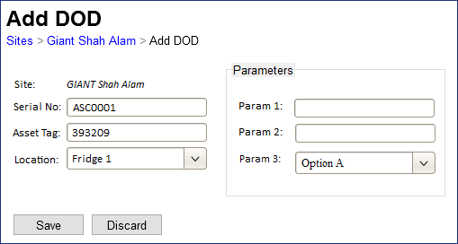

* All fields will be read-only when the screen is visited through view-mode, i.e.: when viewed by a Customer???

## Configuration – A user can view/modify DOD devices for the site

(Points:)

A user can click on The view/modify DOD from a site’s summary screen will lead to a list of DOD devices located on that premise.

* Grid contains a list of all DOD devices.
* Columns:
  + Location – host device of the DOD device
  + Serial No
  + Asset Tag – refers to the dod device
  + Alerts Badge – number of alerts that the device currently has. Clicking on the badge opens the 1.5 Alerts page filtered for that DOD device
  + Edit button – will open the Add DOD loaded with the asset information in Edit Mode. Change the banner from Add DOD to edit DOD.
  + Reports button – will open the Reports page where reports are pre-filtered for that asset/DOD

Figure 3: The Site > “View/Modify DOD” screen on desktop browser

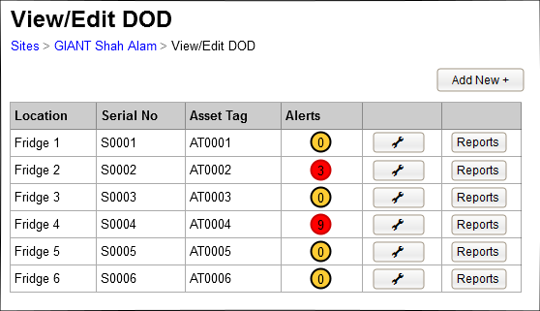

## Configuration – Alerts Page

(Points: )

The site listens to alerts raised by the DOD devices, and stores the alerts history in the database.

* *Shad – lets add to the grid Location, Serial, Asset Tag. And create a filter for location*

Figure 4: Alerts screen

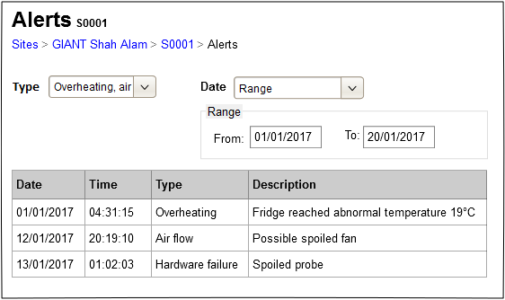

* Default view for the last 24 hours for all types
* User has the ability to filter the grid by changing the type – multi-selection combo box, allows the user to filter the alerts by Alert type. All is the default setting.
* User has the ability to filter the grid by changing the date – combo box, with options:
  + Last Hour – shows only alerts that occurred within the last hour
  + Today (default)
  + This week
  + This month
  + Range – choosing this option will enable the from and to field, which allows the user to choose dates from a calendar control
* Users has the ability to filter by location. All is the default setting.
* Grid developed to include
  + Date & Time
  + Alarm Type
  + Description
  + Location
  + Serial
  + Asset Tag

# Stage 2: Reports

**Objective:** Gathering of information from DOD device data

**Total Point:**

**Total Hours:**

**Weeks:**

## 2.1 Reports – view by DOD

(Points 0)

*Shad pls create screen design*

Accessible form the main menu by the user by clicking reports

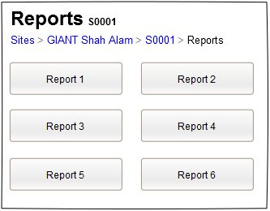

Report1 – DOD Activity

* Default view of current state of temperature and airflow detected the dod device
* Users has the ability to filter by location. All is the default setting.
* Grid developed to include
  + Location
  + Serial
  + Asset Tag
  + Temp in degrees or Fahrenheit
  + Airflow in ? (Preferably a graphic? Puja/Shad pls speak to stuart to confirm requiremnets

Report 2 – HACCP

* Default view of HACCP interval hourly? data pulled yesterday from 12am to 11:59pm from each DOD device and stored on backend tables
* Users has the ability to filter by location. All is the default setting.
* Grid developed to include
  + Location
  + Serial
  + Asset Tag
  + Low – Conbfigured Sepint
  + High – configure setpoint

00,01,02 etc – hours throughout the day

* User can view exscptionin red where tempaeratuie is out side iof threshold Low & High
* User can see the temerparure redings recordedat hourly intervals

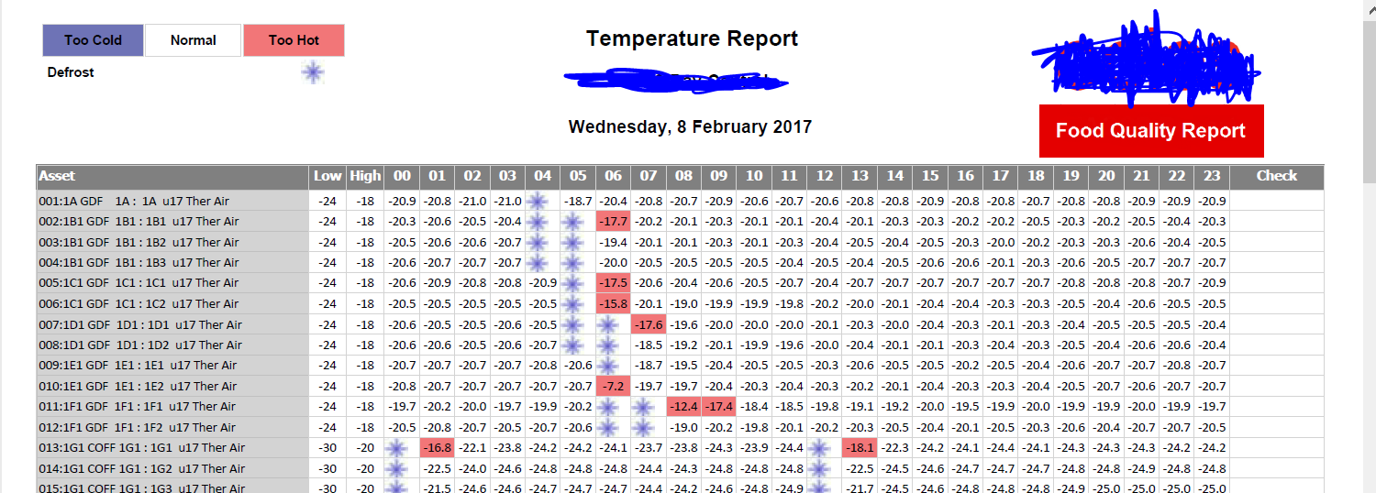

Report 3 – DOD offline /HACCP Exception report all sites

* Mobile view - A user can view by store type in alapahebtical order with a count of the number of dod not reporting temperature data for the last 24hours.
* Mobile view - A user can tap on the + button to expand and show all sites in alphabetical order with a counter of number of number of dod not reporting temperature data foor the last 24hours.
* Mobile view - A user can tap on the + button to expand and show Location, Serial No, Asset in one field

*Shad Pls develop a screen design*

* Report 4 – Puja/Shad pls confirm with stuart any additional reporting requirements

## Configuration – User Roles

(Points: )

Roles:

Shad Pls develop a Settings screen for this

* Technician
* Customer

Permissions:

* View DOD devices
* Add DOD devices to site
* Edit DOD device
* View reports
* Configure alerts
* Configure parameters

|  |  |  |
| --- | --- | --- |
|  | Technician | Customer |
| View DOD devices | Yes | Yes |
| Add DOD deviceS to site | Yes | No |
| Edit DOD device | Yes | No |
| View reports | Yes | Yes |
| Configure alerts | Yes | No |
| Configure parameters | Yes | No |

Greta how is this setup. Configurations screen

# Timeline

|  |  |  |  |  |  |
| --- | --- | --- | --- | --- | --- |
| Stage | Objective | Total Points | Total Hours | Weeks |  |
| Stage 1 |  |  |  |  |  |
| Stage 2 |  |  |  |  |  |
| Stage 3 |  |  |  |  |  |
| Stage 4 |  |  |  |  |  |
| Stage 5 |  |  |  |  |  |
| Stage 6 |  |  |  |  |  |
| Stage 7 |  |  |  |  |  |
| Stage 8 |  |  |  |  |  |
| Total |  |  |  |  |  |

Use the source content from the BSMR (4QD) or HLRSD .

Appendix

A2 Decisions & Implications

[Insert text]

List the key design decisions and implications that this project faces. For example, a specific design for an interface may prevent

A3 Definitions, Acronyms and Abbreviations

For ease of use, sort this table into Abbreviation & Expanded Term sequence.

Add any terms that you think may be confusing to readers of this document. Some terminology is known and taken for granted within a group, but will be unknown to others outside that group. Consider also terminology that has had changed meaning over time.

|  |  |
| --- | --- |
| **Term** | **Definition** |
|  |  |
|  |  |
|  |  |
|  |  |

A3 Table of figures

**No table of figures entries found.**

A4 References

Business Request Brief<application name>

Feasibility Document<application name>

Business Requirements Document, <application name>

Project Charter, <application name>

Project Management plan, <application name>

Solution Architecture <application name>

Business Solution Management Report (4QD only)

High Level Requirements & Solution Definition (4QD Lite only)

DRP Recovery Strategy, A Guideline for Developing